Assignment 3
Fa20-bcs-151
Aamna Zahid
Section: C
Sub. To: Mam Annam Hussain

Protein Name: Lectin

Question No. 1: Interacting proteins
Answer:

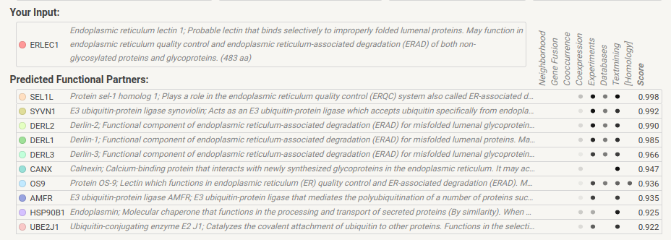

Question No. 2: Pathway
Answer:
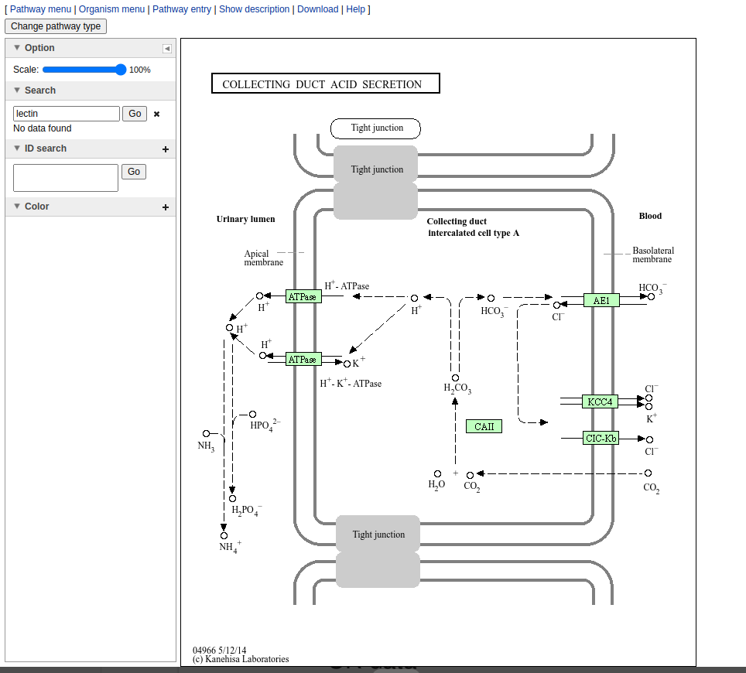

Question 3: Function and domain of protein
Answer:

